Question Bank (I scheme)

Name of subject : CONTROL SYSTEM AND PLC
Subject code : 22531 Unit Test : I
Semester : 5 Course : EJ5I

Chapter 1: Basics of control system (12 marks)
2 marks
- Define open loop and closed loop system with example.
- Give significance of Laplace transform in control system.
- Find the Laplace transform of f(t)= t.
- Define order of the system and find order of following system T(s) = _______(S+5)_______
S(S+2) (S+4)

4 marks
5) Derive the transfer function of system using block reduction techniques.
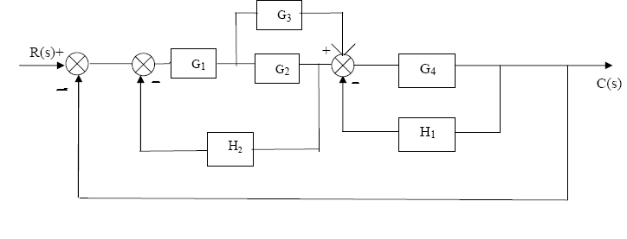 6) For the electrical system shown in fig. No.1, Derive the transfer function Vo(s)/Vi(s)
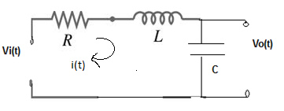
7) Compare open loop and closed loop system.
8) Define transfer function and derive the transfer function for a general closed loop control system.
9) State any four block diagram reduction rules.

Chapter 2: Time domain stability analysis ( 16 marks)
2 marks
10) Define the terms : i) Poles ii) Zeros

- For a system having closed loop transfer function for unit step i/p determine
1) wn 2) damping factor

T(S) = _______64________
S² + 5S + 64
- Define i) steady state error ii) Type of the system
- Define i) damping ratio ii) transient response
- Define the following terms Stable System and Unstable System.
- State Routh’s stability criterion. State their advantages.

4 marks
16) For the given transfer function C(s)/R(s) = (S+2)/S(S²+ 2S+ 2)(S²+7S+12)
Find Poles, Zeros & Characteristic Equation
- Draw the time response of second order underdamped control system with neat labeling.
- Derive unit step response of 1st order system.Draw the response.
- A second order system is given by
T(S) = _______25________
S² + 6S + 25
Determine time domain specifications.
i) Rise time ii) peak time iii) settling time iv) peak overshoot
- Find error coefficients and steady state error for the transfer function
G(s).H(s) = 10 (s+1)_______
s.(s+2)(s+5)
where r(t)=3+10t
- What are the standard test signals used in time domain analysis and state the mathematical statement for each.
- Determine the stability of the system whose characteristic equation is given as
S⁶+2S⁵+8S⁴+12S³+20S²+16S+16=0
- A system has G(s).H(s) = _______ _K__________
S(S+2) (S+4) (S+8)
where K is positive. Determine the range of ‘K’ for the system to be stable.

Chapter 3: Process Controllers ( 10 marks)
2 marks
24) Define the following terms:-
*Proportional band * offset
25) Compare P, I & D control action on the basis of
i) nature of output ii) equation
4 marks
26) With neat diagram, describe on-off controller
27) Explain neutral zone with neat diagram.
28) Explain the PID control action.
29) List two application & two drawbacks of PI controller.
30) Compare P control action with PI control action.

